NAME:ANUPRIYA.S

REG NO:727722EUIT502

SOFTWARE TESTING CC2

YATRA:



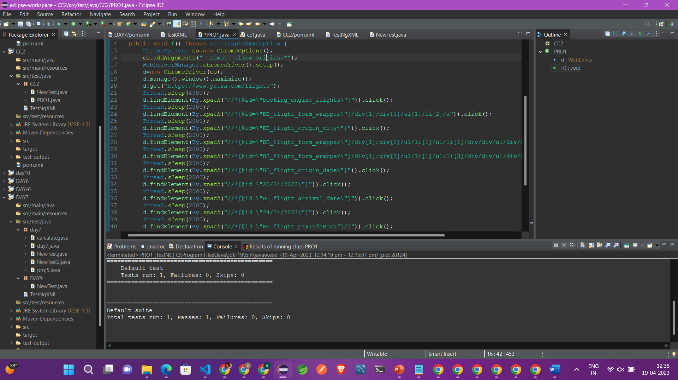

OUTPUT:



